# Project Report

1.default mode

Running server



The port number is set to be 34567, if you want to change the value of it , you could open server.c ,and change it in main function as below:

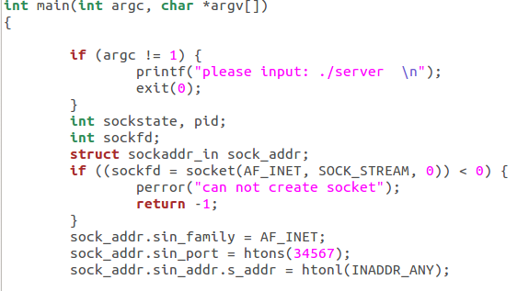

Running client

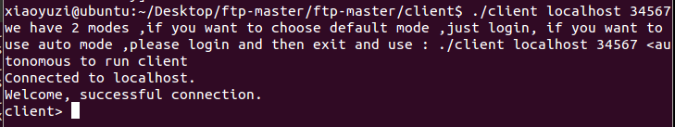

Login

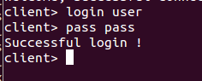

ls command

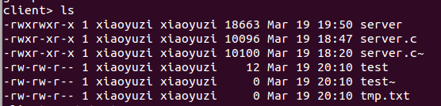

get command



Then use this port to get server.c, we run another terminal and using cd command to enter the client directory, then using nc localhost 5886 to download test



Then check the server folder

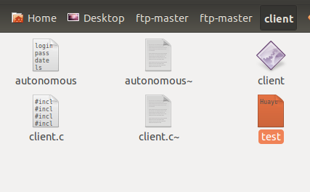

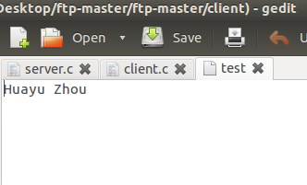

Download succeed!

Finally exit



Other method we use auto mode to check.

I fail to implement put command, I am sorry for that ,And I will fix it soon.

2.autonomous mode

Using file relocation method to implement auto mode .Using command ./client localhost 34567 <autonomous

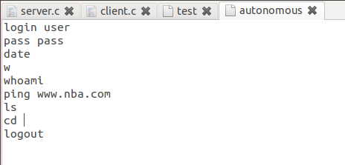

Server side:

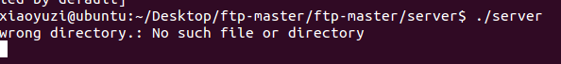

Client side:

